*Möhlenhoff offers the ideal way of entering the Smart Home growth market*

**Intelligent networking for better comfort, reliability and energy efficiency in the home**

**Salzgitter, April 2016 – Digital networking in private homes is also on the rise. The trend towards Smart Homes is gaining in importance and is becoming the focus of general interest. With this concept, individual components of domestic and public everyday life, such as heating, lighting and security systems for example, are interconnected and controlled via an intelligent home automation system. With the automation of everyday actions, users benefit from better comfort and security and also save money. The Smart Home technology with its almost limitless expandability also offers tremendous potential for suppliers.**

Modern buildings are networked, automated – and intelligent. They automatically increase the temperature and switch the lights on when the occupants come home, and lock windows and doors when they leave. With Smart Home, these scenarios become normality. For a long time, the networked home has been more than just a feature of the high-price segment or gadget market, and now enriches everyday life in many homes and public buildings such as offices, hotels and schools. Home automation offers a practical, comfortable and reliable solution for nearly all situations in domestic life. For example, a window can be connected to the heating system by means of a tilt sensor to close the control valve automatically when the window is opened. At the same time, the window sensor can be used to detect a break-in.

**Globally connected in the Internet of Things**

A total of 20 billion things throughout the world already have their own IP address together with a chip or sensor and are connected to the Internet. Communications technologies enable them to be identified and automatically interact with one another. The future concept “Internet of Things” is coming palpably closer. The new technology is already widely established, particularly in industry and logistics and also in building technology, and forms the basis of new business models. For companies in all sectors, such as system providers, equipment and system producers, companies in the automobile, IT and telecommunications industries, entertainment electronics and manufacturers of domestic appliances and safety equipment, networking offers a good opportunity to position themselves long-term on the digital market. The particular advantage is that companies benefit both from their expert knowledge accumulated over many decades and from the innovative digital technology – thus remaining viable for the future.

**Intelligent communication as a basis for the Smart Home**

The main difference between the conventional building and the Smart Home lies in the communication between the individual devices, sensors and systems. The modular design and intelligent networking via IP enables many scenarios to be realized in a Smart Home. These are geared towards the conditions in private homes and the occupants’ individual needs and requirements and can be expanded at will. Once the individual components have been connected and matched to one another, they communicate and respond automatically. Users can control and operate all the connected modules comfortably using an app. Daily recurring actions can be programmed in just a few steps and thereafter organize themselves without any intervention, which makes for a considerable increase in convenience.

**The networked home ensures high energy efficiency**

The average citizen uses most energy at home for heating his living rooms. Particularly in the transition periods of spring and fall when considerable temperature variations can occur, an enormous amount of heat energy is lost and unused. A problem, which in the Smart Home with an intelligent heating control system, can be easily and effectively solved. The user simply controls the temperature by means of the networked radiator thermostats locally on the home network or, when out and about, by smartphone. He can interrogate the status of the building or room, review the previous temperature pattern, and in this way optimize energy efficiency. Recurring standard actions can be conveniently defined using scenarios and time profiles. By targeted heating – particularly in rooms which cool down quickly – this enables energy savings of up to 30% to be achieved in the course of the day.

Heating, ventilation and air conditioning specialist Möhlenhoff offers a particularly innovative solution for the Smart Home. OEM Alpha IP is a home automation system which uses the eQ-3 Homematic IP communications standard and can be expanded in future by the addition of numerous components. Based on the IPv6 transmission standard, individual components are addressed and controlled individually and reliably using radio signals. This ensures optimum interaction between all components involved – and therefore high energy efficiency.

**Easy installation and intuitive control**

OEM Alpha IP impresses throughout with its simple and user-friendly operation. Easy installation, which can be carried out by a local dealer or even by the end user himself, simplifies the incorporation of a home automation system and the connection of further components. Möhlenhoff‘s OEM Alpha IP air conditioning solution can be straightforwardly set up and intuitively controlled using the intelligent user guidance provided by the free Alpha IP app. Installation of the individual components practically takes care of itself, as all necessary connections between the devices are made automatically.

The Alpha IP product range provides the ideal basis for almost unlimited combination and expansion options. It starts with seven heating control products together with apps and cloud software. Among other things, the range includes a radiator thermostat and different room controls, a switched measuring socket and an optical window and door contact. These enable every user to put together exactly the right solution to best suit his existing installation.

**Multifaceted security**

The Smart Home provides optimum protection in a number of ways. On the one hand, by means of networked security systems: alarm installations and movement sensors as well as smoke and water detectors can be integrated into the home automation system without difficulty and give early warning of hazards – including by app if the occupants are not at home. Internal communication between the individual devices and sensors enables the source of the hazard to be localized particularly quickly and saves valuable time in an emergency. On the other hand, the highest security standards offer effective protection against hacker attacks. Möhlenhoff‘s OEM Alpha IP also ensures optimum data protection. The user’s address information is not stored or saved and therefore no movement profile is created. Furthermore, only servers in Germany are used to manage data stored externally in the cloud. The encrypted bidirectional wireless protocol for the individual components also ensures secure, smooth and error-free communication.

**Ideal entry point for OEM customers**

The Smart Home is comfortable, secure and energy efficient. It not only has numerous advantages for end customers, but also opens up a wide range of possibilities on the up-and-coming digital market for system providers, manufacturers of home and security equipment, and device and system producers. As an OEM partner, Möhlenhoff supplies different system solutions which enable customers to decide whether to offer only underfloor heating components which are compatible with home automation, selected heating control modules, or the full range for the Smart Home. Home automation systems, such as Möhlenhoff‘s OEM Alpha IP, provide an ideal entry point into the lucrative Smart Home segment – and therefore into the future-oriented concept “Internet of Things”.

Author: Björn Nahler, Product Marketing, Möhlenhoff GmbH

*7,911 characters incl. spaces*

**Captions:**

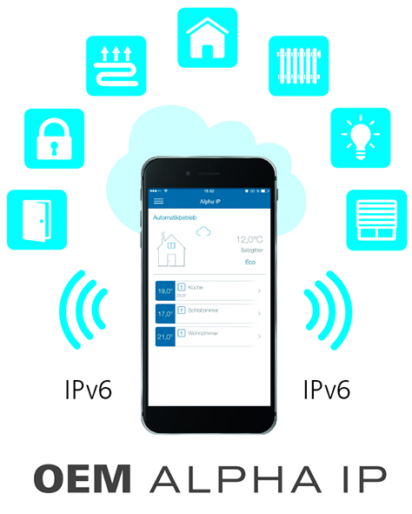

**Image 1:** Möhlenhoff's innovative OEM Alpha IP home automation system is based on eQ-3's Homematic IP communication protocol.

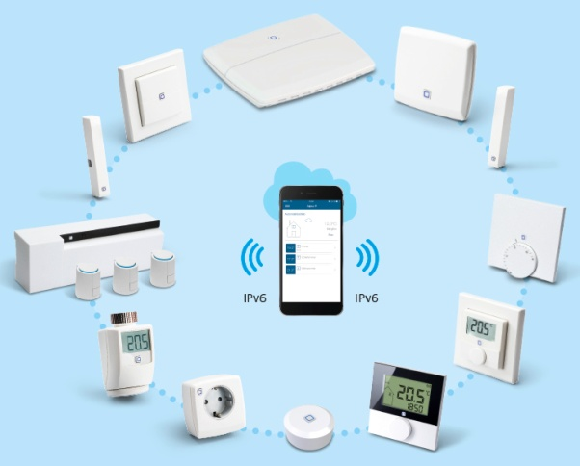

**Image 2:** Möhlenhoff’s Alpha IP range provides the ideal basis for numerous combinations and expansions.

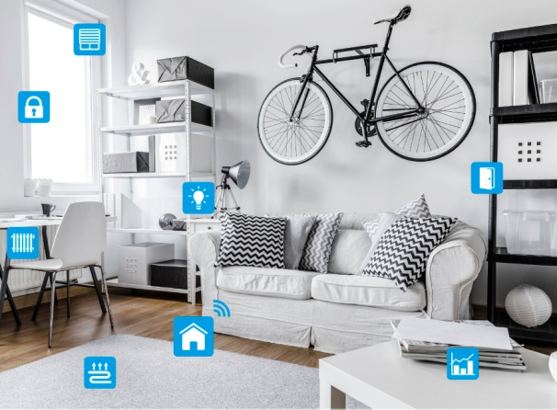

**Image 3:** The OEM Alpha IP Smart Home system networks individual components in domestic everyday life and ensures a high level of comfort.



**Image 4:** OEM Alpha IP can be straightforwardly set up and controlled by app using a smartphone.

**Images: Möhlenhoff GmbH Salzgitter**

**Möhlenhoff GmbH**

Based in Salzgitter, Germany, Möhlenhoff GmbH is a supplier of products and systems for the heating, ventilation and air conditioning industry. The company specializes in the development and manufacture of solutions for electronic room-by-room temperature control, smart home technology and underfloor convectors. Möhlenhoff is the global market leader in the field of thermal actuators. Over a period of more than 30 years, the company has established itself as a reliable, expert partner for OEM customers in these sectors. In 2015, the company's 192 employees achieved sales of 39.4 million euros.