*Möhlenhoff at the ISH 2017:*

**Innovative room-by-room solutions for the future**

**Möhlenhoff will be presenting its extensive portfolio at the ISH, the world's leading trade fair for the bathroom experience, building, energy, air-conditioning technology and renewable energies (14th–18th March 2017, Frankfurt am Main, Germany). Among other attractions, visitors can look forward to seeing the extended range of products available for the innovative OEM Alpha IP smart home system. They will also be able to discover the universal room-by-room temperature control system for heating and cooling applications OEM Alpha 2 that can be integrated quickly and easily in existing home automation systems via an XML interface. What is more, Möhlenhoff has further developed its energy-efficient OEM Actuator 5 series to include the Smart Valve Drive and Motoric Valve Drive devices. The latter of these is available for all variants with immediate effect.**

With its comprehensive home automation system OEM Alpha IP, Möhlenhoff offers OEM customers a complete system to easily enter the growing "Smart Home" market. All heating systems, from surface heating systems through radiators and on to electric heating, can be perfectly regulated and conveniently controlled using this intelligent system. The up-to-date product portfolio is rounded off by new components for security and intrusion protection as well as for lighting control. The OEM Alpha IP system is easy to install and intuitive to operate – even via smartphone when the user is away from home. Users benefit from a better quality of life, an enhanced home environment, comfort, intrusion protection and a high level of long-lasting system reliability. What is more, the networked home also cuts energy costs.

And there is more to see: The actuators in the OEM Actuator 5 product family. With power consumption of approximately only one watt, these are the most energy-efficient units of their type on the market. Covering a range of actuator types and design variants, the series offers the perfect solution for every area of application. The Smart Valve Drive actuator is particularly well suited for distributors with small valve distances. The Motoric Valve Drive is a motoric actuator that excels wherever a rapid control response is required independently of the temperature. It has a stroke of 8.5 millimeters and the different variants offer actuation forces of 100, 125, 150 and 200 Newtons. The actuator also boasts IP54 waterproofing in all assembly positions, can be supplied with an illuminated display and is compatible with the Möhlenhoff valve adapter system. It can therefore be connected to the valve quickly and easily.

The OEM Alpha 2: system is a universal room-by-room control system for heating and cooling applications. Möhlenhoff has equipped the surface heating system with the latest generation of wireless room sensors. These measure the room temperature and humidity discreetly and accurately. Thanks to “Smart Home Ready”, users can integrate the OEM Alpha 2: system into existing home automation systems conveniently and reliably via an open XML interface. Different individual systems and products are combined via XML and can communicate with one another in the core network using the Internet Protocol (IP). This permits the intelligent, energy-saving coordination of all the participating components. Operation is performed using a room thermostat (e.g. the Alpha 2: room controls with display) via the home network or from a smartphone when the user is away from home.

With its innovative products and systems, Möhlenhoff offers OEM customers an ideal way into the lucrative smart home segment. The specialist for heating, ventilation and air conditioning solutions adapts all the components in its room-by-room control portfolio individually to meet its customers' wishes and offers them many different opportunities for differentiation. These extend from the function scope through the printing of logos and markings and on to customer-specific housings, tailor-made packaging and communications tools.

**Möhlenhoff at the ISH 2017: Hall 10.1, Stand A 19**

*4,135 characters incl. spaces*

**Meta-Title**: ISH 2017: Möhlenhoff will be presenting the room-by-room temperature controls of the future*:*

**Meta-Description**: At the ISH 2017, Möhlenhoff will be presenting its innovative room-by-room temperature controls in the form of the Alpha IP smart home system and the OEM Alpha 2: system.

**Keywords**: Möhlenhoff room-by-room temperature control smart home heating and air-conditioning technology energy-efficient surface heating system actuators

**Captions:**

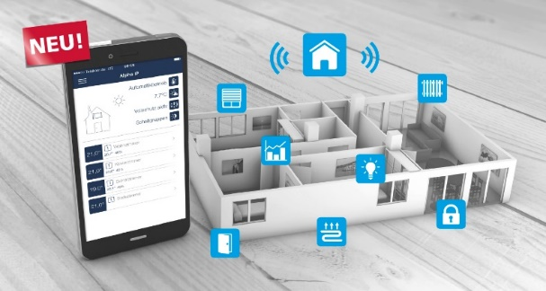

**Image 1:** The innovative home automation system OEM Alpha IP offers OEM customers the ideal entry-level system for the growing "Smart Home" market.

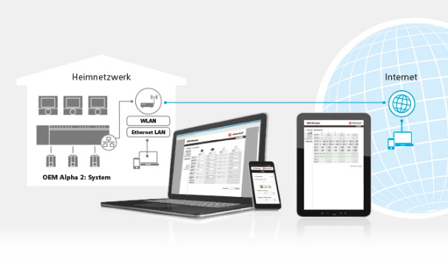

**Image 2:** With the OEM Alpha 2: system, users can operate heating and air conditioning components conveniently from a laptop, tablet or smartphone – either within the home network or over the Internet.



**Image 3:** Möhlenhoff's OEM Actuator 5 consumes up to 45 percent less electricity than other actuators.

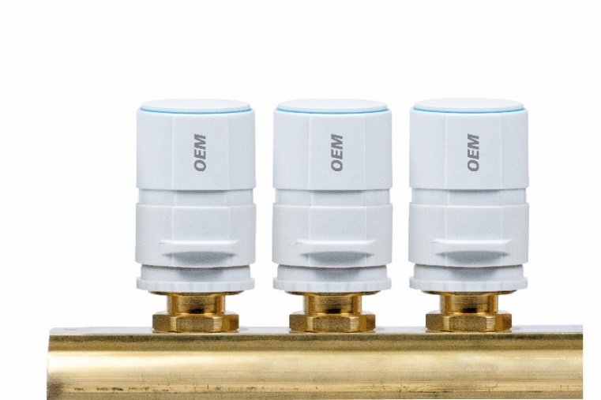

**Image 4:** Möhlenhoff's portfolio includes the Smart Valve Drive with a stroke of 3.5 millimeters and actuating force of 90 Newtons for installation in confined spaces.

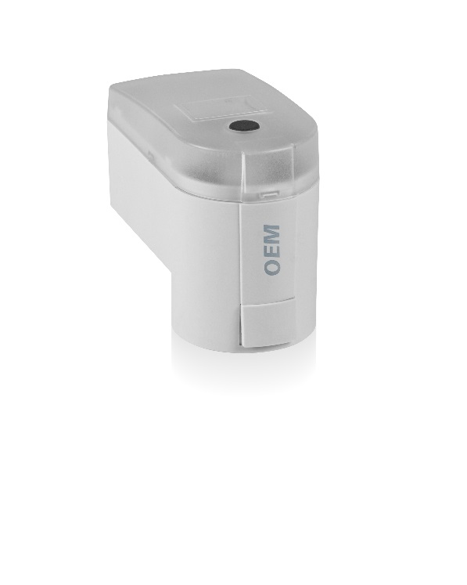

**Image 5:** The Motoric Valve Drive motoric actuator has a stroke of 8.5 millimeters and is available with actuating forces of 100, 125, 150 and 200 Newtons.

**Images: Möhlenhoff GmbH Salzgitter**

**Möhlenhoff GmbH**

Based in Salzgitter, Germany, Möhlenhoff GmbH is a supplier of products and systems for the heating, ventilation and air conditioning industry. The company specializes in the development and manufacture of solutions for electronic room-by-room temperature control, smart home technology and underfloor convectors. Möhlenhoff is the global market leader in the field of thermal actuators. Over a period of more than 30 years, the company has established itself as a reliable, expert partner for OEM customers in these sectors. In 2016, the company's 180 employees achieved sales of 41.6 million euros.