Möhlenhoff displays intelligent room-by-room solutions at the MCE 2018:
For the connected home of the future

Salzgitter, January 2018 – The heating, ventilation and air conditioning specialist Möhlenhoff will be exhibiting for the fourth time at the MCE – Mostra Convegno Expocomfort (13th to 16th March 2018, Milan/Italy). At the international trade fair for installation technology, air conditioning technology and renewable energies, Möhlenhoff will be exhibiting selected products from its extensive portfolio. The company's trade fair stand will shine the spotlight on the OEM Alpha IP intelligent smart home system, together with a number of other solutions. In addition, visitors will be able to find out all they need to know about the OEM Alpha Air air management system.

With Alpha IP, Möhlenhoff is exhibiting a home automation system that offers OEM customers the ideal entry-level solution for the growing “Smart Home” market. All heating systems, from surface heating systems through radiators and on to electric heating, can be optimally regulated and conveniently controlled using this intelligent system. Taking the key theme of heating as its starting point, the company will this year also present not only security and lighting components but also shading solutions. The overall system has a modular structure and can be individually extended as required – for example with new intrusion detection systems or components for the measurement of consumption or for controlling roller shutters or blinds. One great advantage lies in the system's user-friendly design and intuitive operation. Users can operate the system easily and conveniently via a free app installed on their smartphones – or using voice control. Alpha IP increases indoor comfort, offers outstanding reliability of operation and tamper protection and provides considerable potential energy savings and the guarantee of an investment that will prove its worth in the future.

At the MCE, Möhlenhoff will be exhibiting its OEM Alpha Air air management system for the first time ever in Italy. The demand-based, flow-rate control solution for residential ventilation solutions extends conventional centralized ventilation systems by providing a central unit and air distribution system. The independent control system uses volumetric flow regulators coupled with a central control unit to adapt the room-by-room volumetric air flows as required in response to sensors installed in the individual rooms. Fresh air is therefore only provided where it is actually needed. This makes energy savings of up to 30 percent possible. What is more, Möhlenhoff is currently developing a variant that can be used as a fully-featured fresh-air heating solution. OEM Alpha Air is compatible with Alpha IP and can also be integrated in other smart home systems. The solution can be set up and controlled quickly and easily via an app.

OEM Alpha 2: system will also be on display in Milan. This is a universal room-by-room controller for heating and cooling applications. It is available as both a BUS and radio-controlled variant. Users can operate it quickly and easily in the home network or over the Internet using a laptop, tablet or smartphone. Using Smart Home ready, the system can be easily integrated into an existing home automation system over an open XML interface. With the cabled OEM Alpha direct: system, it is possible to implement even complex room-by-room control solutions economically and reliably. The solution is suitable for both new constructions and modernization projects. In addition, visitors to the trade fair will also be able to see the OEM Actuator 5 series of thermal actuators. With power consumption of approximately only one Watt, these are the most energy-efficient units of their type on the market. The Smart Valve Drive actuator for particularly small valve distances and Möhlenhoff's motoric actuator, the Motoric Valve Drive, round off the product portfolio.

Möhlenhoff at the MCE 2018: Hall 11, Stand S41

Meta-Title: Möhlenhoff presents solutions for the smart home sector at the MCE 2018

Meta-Description: At the MCE, the company's trade fair stand will shine the spotlight on the OEM Alpha IP smart home system and the new OEM Alpha Air air management system

Meta-Tags: Heating, ventilation and air conditioning specialist Möhlenhoff MCE – Mostra Convegno Expocomfort 2018 Smart Home OEM Alpha IP OEM Alpha Air OEM Alpha 2: System OEM Alpha direct: System Smart Valve Drive Motoric Valve Drive

Captions:
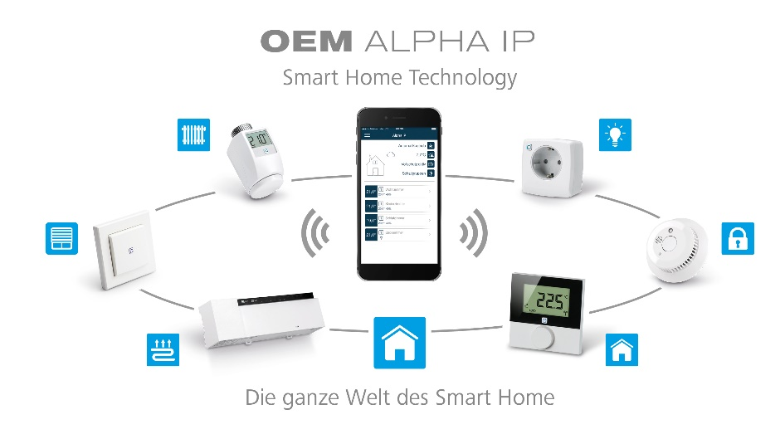
Photo 1: Möhlenhoff's innovative home automation system OEM Alpha IP offers OEM customers the ideal entry-level system for the growing "Smart Home" market.
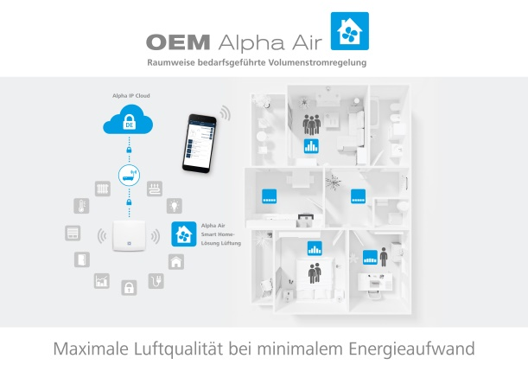
Photo 2: At the MCE 2018, Möhlenhoff will be exhibiting its OEM Alpha Air air management system for the first time.

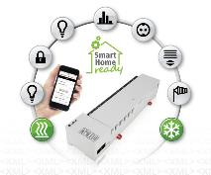
Photo 3: With the OEM Alpha 2: system, users can operate heating and air conditioning components conveniently from a laptop, tablet or smartphone – either within the home network or over the Internet.

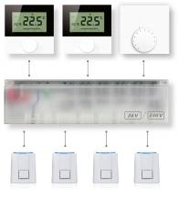
Photo 4: Also on display at the MCE: The cabled OEM Alpha direct: system, which makes it possible to implement even complex room-by-room control solutions economically and reliably.

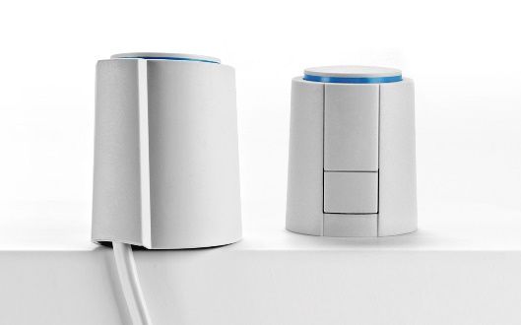
Photo 5: With a power consumption of just one Watt, the OEM Actuator 5 family of products are the most energy-efficient units of their type on the market.

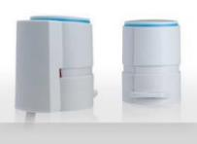
Photo 6: Möhlenhoff's portfolio includes the Smart Valve Drive with a stroke of 3.5 millimeters and actuating force of 90 Newtons for installation in confined spaces.

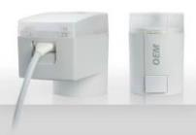
Photo 7: The Motoric Valve Drive is a motoric actuator with a stroke of 8.5 millimeters and actuating force of up to 200 Newtons.

Photo credits: Möhlenhoff GmbH, Salzgitter

Images: Möhlenhoff GmbH Salzgitter

Möhlenhoff GmbH
Based in Salzgitter, Germany, Möhlenhoff GmbH is a supplier of products and systems for the heating, ventilation and air conditioning industry. The company specializes in the development and manufacture of solutions for electronic room-by-room temperature control, smart home technology and underfloor convectors. Möhlenhoff is the global market leader in the field of thermal actuators. Over a period of more than 30 years, the company has established itself as a reliable, expert partner for OEM customers in these sectors. In 2017, the company's 180 employees achieved sales of 46, 2 million euros.

